White Rose 1-Minute Maths
You can challenge your child daily and build their fluency skills by downloading the free 1-minute maths app from White Rose Maths.
Click the link below to download the app.
https://whiteroseeducation.com/1-minute-maths
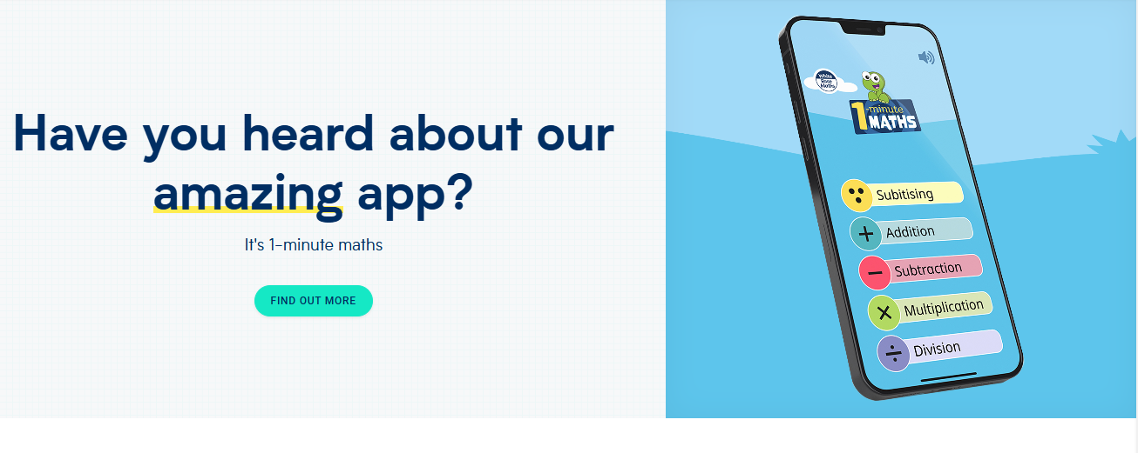
Once downloaded you can select the topic you would like to challenge your child on. There is something for everyone from Subitising numbers within 10 to multiplication and division. (See examples below)


