White Rose Maths Home Learning Resources

You can support your child with their maths homework by accessing all of the White Rose Maths home learning lessons for early years through to Year 6 for free.

Every lesson comes with a short video showing you clearly and simply how to help your child complete the activity successfully.

Click on the link below to access the lessons.
https://whiteroseeducation.com/parent-pupil-resources/maths/home-learning
Once you get onto the parent-pupil homepage just select the year group your child is in from the drop down menu and click on filter.
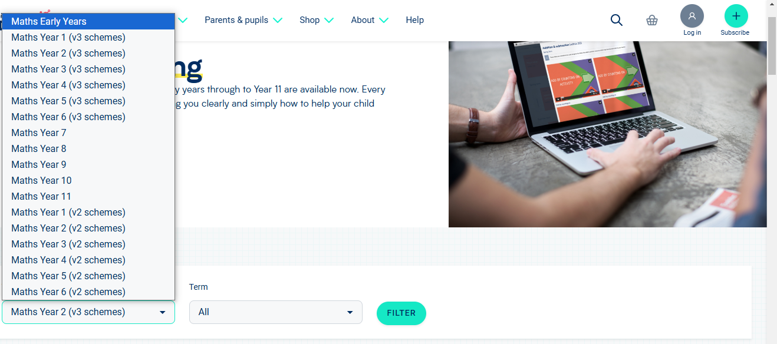
This will then bring up the yearly overview for the year group. (See example below)
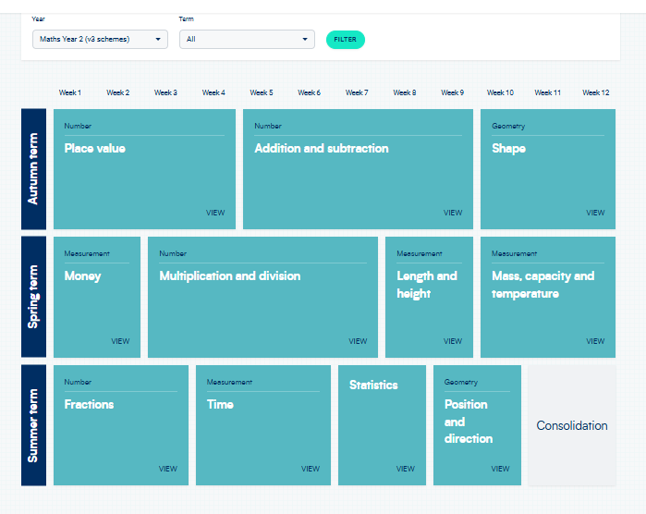
Select the topic your child is working on in school and access the lesson videos. (See example below)


