Mathematical Fluency Policy

Compiled by: | Alex Miller and Aysha Vachhiyat
Presented to staff: | September 2024
Presented to Governors: | September 2024
Presented to Parents/Carers: | September 2024
To be reviewed: | Every 3 years or sooner if required
Review dates:

Amendments:

Fluency Policy

Fluency involves;
- Quick recall of facts and procedures
- The flexibility and fluidity to move between different contexts and representations of mathematics.
- The ability to recognise relationships and make connections in mathematics
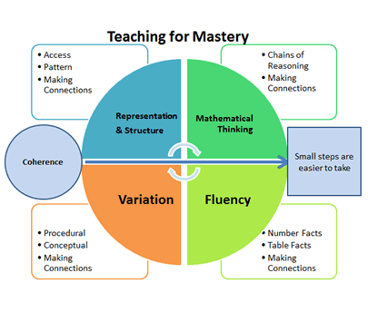

Fluency is one of the ‘Five Big Ideas’. These are principles drawn from research evidence that underpin a ‘Teaching for Mastery’ approach. Fluency goes hand-in hand with the other ideas that lie at the heart of maths mastery pedagogy.

A child who is fluent in key maths facts has the ability to quickly and efficiently recall facts and procedures and has the flexibility to move between different contexts and representations of mathematics.

At Intack Primary School there is an emphasis on the importance of developing fluency with mathematical facts. Mathematics lessons begin with a fluency activity. Children are also given regular opportunities within and outside of maths lessons to practice basic facts and develop flexibility with these facts.

A CPA (concrete – pictorial – abstract) approach is followed Intack Primary School which supports the development of fluency with key concepts. A number of concrete, pictorial and other resources are used at in school to develop the understanding of basic facts and help children to become fluent in basic maths facts. Children may use the following resources to help secure fluency with number facts: stem sentences, Numicon, ten frames, Rekenreks, bar models, part-whole models, counters and Dienes apparatus. Children develop their understanding of basic facts with concrete resources first before moving on to representing numbers and facts pictorially and then abstractly. When fluency with a fact develops children will no longer need resources and will be able to automatically recall that fact within three seconds. At Intack Primary School there is a drive on fluency throughout school. This is being supported by an emphasis on concrete and pictorial representations of number in the Early Years and Year One.

What is a CPA approach?

Concrete: The ‘doing’ stage. Using physical objects to understand a concept and solve maths problems.
Pictorial: The ‘seeing’ stage. Using visual images to support conceptual understanding and solve maths problems.
Abstract: The ‘symbolic’ stage. Using numbers and symbols to solve and understand maths problems.

Children in Reception and Key Stage One take part in the NCETM Mastering Number Programme Project. This project aims to secure firm foundations in the development of good number sense for all children from Reception through to Year 1 and Year 2. The aim over time is that children will leave KS1 with fluency in calculation and a confidence and flexibility with number. Attention will be given to key knowledge and understanding needed in Reception and progression through KS1 to support success in the future. All Reception and Key Stage One children have a daily 10 – 15 minute ‘Mastering Number’ session following the systematic and progressive programme to further support the development of fluency with key number facts.

- Developing fluency in addition and subtraction facts -Why focus on fluency in addition and subtraction facts?

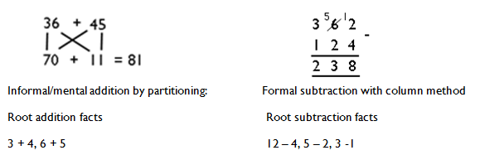
- A defined set of addition and subtraction facts build the basis of all additive calculation, just as times tables are the building blocks for all multiplicative calculation:

- If children are not fluent in these facts, then when they are solving more complex problems the working memory is taken up by calculating basic facts, and children have less working memory to focus on solving the actual problem so fluency in basic facts allows children to tackle more complex maths more effectively.
- Fluency is one of the 3 aims of the national curriculum, and external tests focus heavily on fluency.
- Children need to be taught strategies to solve these facts. If children aren’t explicitly taught to solve e.g. 6+7 by thinking ‘double 6 and one more’ or to solve 12 – 8 by thinking ‘2 more and 2 more again’ then most children will use inefficient counting-based approaches.

What facts do children need to be fluent in?
Children need to be fluent in the following addition facts:

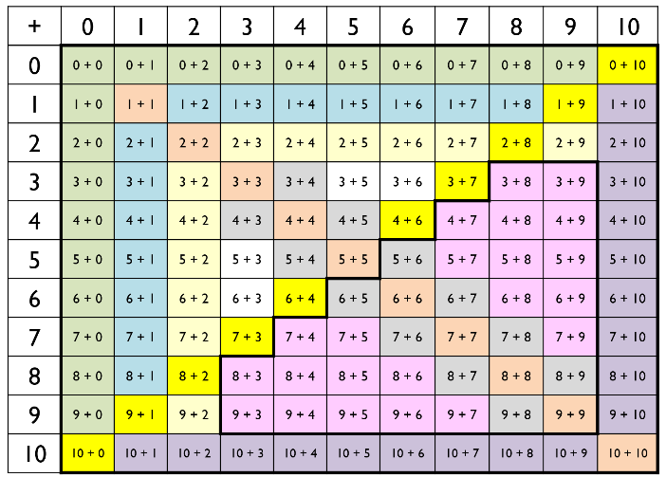

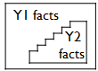

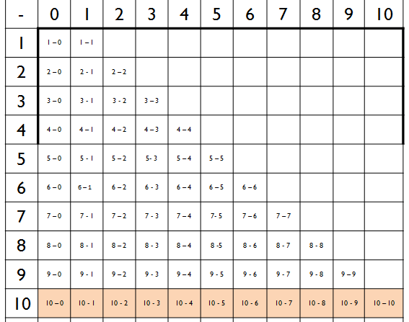
These are the corresponding subtraction facts:

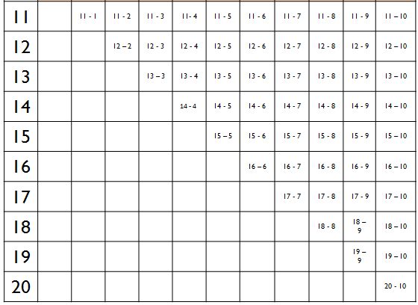

Note that not all subtractions within 20 are root facts, e.g. 17-5 is not considered a root fact (7-5 is the root fact for this).
The majority of these facts will be learnt in Year 1 and Year 2. In Reception, children become fluent in working with totals to 5 (though not recording as equations), e.g. “Show me 5 on your hands. Now show me 5 in a different way.” Year 3 will need to focus on securing fluency in subtraction facts which bridge 10. Although this is a Year 2 objective, aiming for real fluency in subtraction facts such as 14 – 9 and 13 – 5 (where fluency is an answer in 3 seconds) requires securing in Year 3.

Does fluency just mean memorisation?

Not necessarily – most rely on very quick use of strategies to solve some of them. Fluency can mean getting an answer quickly and with limited demands on working memory.
Most facts which don’t bridge 10 are memorised, 4 + 5 = 9 or 2 + 6 = 8 for example.

For facts which bridge 10, the picture is more complex and many of the facts which bridge 10 are quickly derived using strategies (but still in less than 3 seconds).
  - Double 6, 7 8 and 9 can be memorised in fluent children.
  - Many fluent children may ‘just know’ that 9 + 3 = 12 and 8 + 4 = 12 and relate this to their times table/skip counting knowledge.
  - Fluent children use strategies for many of the other facts. E.g. 9 + 8 –with fluency this can be solved through very quickly applying a strategy: bridging, near doubles or compensating.
The grid below demonstrates approaches taken by a fluent, high attaining Year 4 child to each of the addition facts: no counting approach was used for any of the facts, but they are not memorised either (K= Known fact; S= Strategy). The child attends a school within our Maths Hub.
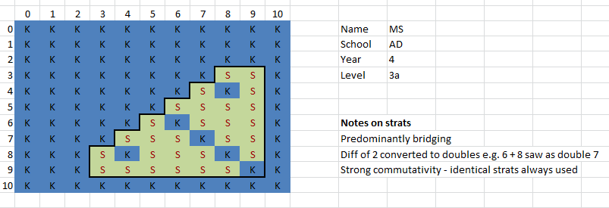

How do children become fluent?
Children need to be taught strategies to derive the facts. Teaching strategies are more effective in securing fluency in addition and subtraction facts than taking a rote memorisation approach.

Suggested progression

Group A: Year 1 (Within 10)

- Adding 1 (e.g. 7 + 1 and 1 + 7)
- Doubles of numbers to 5 (e.g. 4 + 4)
- Adding 2 (e.g. 4 + 2 and 2 + 4)
- Number bonds to 10 (e.g. 8 + 2 and 2 + 8)
- Adding 10 to a number (e.g. 5 + 10 and 10 + 5)
- Adding 0 to a number(e.g. 3 + 0 and 0 + 3)
- The ones without a family! 5 + 3, 3 + 5, 6 + 3, 3 + 6
Knowing these facts by the end of Year 1 will mean children will know 87 of the 121 addition facts in the grid.

Group B: Year 2 (Bridging 10)
Children have 34 addition facts left to learn - they are the ones which bridge 10. While a few adults have instant recall of all of these, most rely on strategies for some. Our aim for children is that they use known facts or derived fact strategies to quickly recall or derive each fact. We need to ensure that all children move beyond counting based strategies. This will require careful teaching of the strategies combined with plenty of practice.
Note that these 3 strategies can often be used interchangeably, e.g. for 8 + 9, some people will use near doubles (e.g. 8 + 8 + 1), some will use bridging (e.g. 8 + 2 + 7) and some will use compensating (8 + 10 – 1)

- Doubles of numbers to 10 (e.g. 7 + 7)
- Near doubles (e.g. 5 + 6 and 6 + 5)
- Bridging (e.g. 8 + 4 and 4 + 8)
- Compensating

N.B. Before the children are ready to learn bridging as a strategy, they need to be able to partition all single digit numbers, therefore the following facts need to be taught alongside the above facts:

- Partitioning 2, 3, 4, 5, 6 and 10
- Partitioning 7, 8 and 9
- Partitioning 11 – 20 into single digit addends

Once children have been taught the strategies, they need to move on to PRACTISE of the facts. The aim is for an average of 3 seconds or less per fact.

Generally, for practise

- We focus on practising the set of facts being learnt (or just learnt) in isolation for a few days
- We focus on mixing these up with all previously learnt facts

For each of these 11 steps, a suggested teaching approach is laid out below, including manipulatives/images, key teaching points and a suggested teaching progression.

Step 1: Adding 1 to a number

Images/manipulatives


A numbered number line



Numicon pieces

Key teaching points

1st key point: Adding 1 to a number is the same as ‘1 more than’ that number
2nd key point: Commutativity 7 + 1 = 1 + 7

Teaching progression:

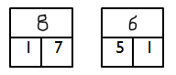
Concrete: Use equipment and a numbered number line to be able to say what is 1 more than any number to 10.

Pictorial: Represent this knowledge in part-part-whole
Diagrams

Abstract: Record this knowledge using number sentences; Model that these can be expressed commutatively 1 + 7 = 8 or 7 + 1 = 8

Model that these can also be expressed as partitioning the whole 8 = 1 + 7 or 8 = 7 + 1

Step 2: Doubles of numbers to 5

Images/manipulatives
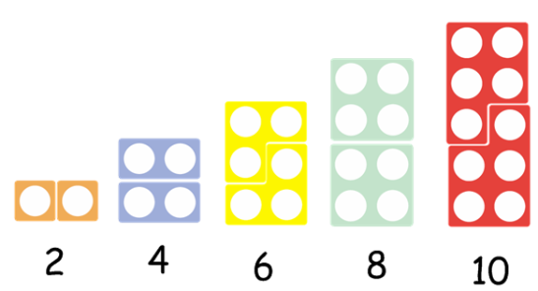

Numicon pieces

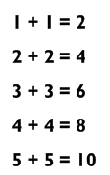
Doubles written up

Key teaching points

1st key point: Our doubles of numbers to 5 are all even numbers [as appropriate you can lead children to the idea that doubling a whole number always gives us as even number]
2nd key point: We need to learn our doubles off by heart!

Teaching progression:
Awareness of odd and even: Be able to identify numbers as odd or even,
using Numicon as a visual image
Fluency in odds and evens counting: Practice counting in even numbers
Understanding of what doubles is: “Double 5” = “Two lots of 5” [spoken] = 5 + 5.
Can the children show you these with Numicon pieces or fingers on each hand?
Noticing patterns: Look as a class at the doubles pattern and relate to even numbers
PRACTICE: Now you need to play LOTS of doubles games until the children all know their
doubles of numbers to 5 off by heart. This is one of the sets which the children just need to memorise.
Represent in part-part whole models and in number sentences.
Step 3: Adding 2 to a number

Images/manipulatives
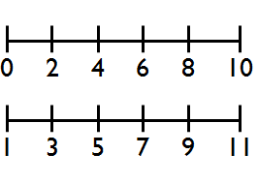
An evens number line etc.
An odds number line etc.

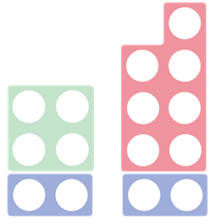
Numicon pieces

Key teaching points
1st key point: When we add 2 to a number, we are working within our odds and evens counting pattern
2nd key point: Commutativity 7 + 2 = 2 + 7

Possible teaching progression:
Awareness of odd and even: Be able to identify numbers as odd or even, using Numicon as a visual image
Fluency in odds and evens counting: Practice counting in odds and evens to 20, forwards and backwards until fluent. Use odd and even number lines for support.
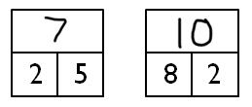
Concrete: Use Numicon to see that when we add 2 to a number (or when we add a number to 2) we are just making the next odd/even number.
Pictorial: Represent this knowledge in part-part-whole
Diagrams

Abstract: Record this knowledge using number sentences; Model that these can be expressed commutatively and by partitioning the whole

Step 4: Number bonds to 10

Images/manipulatives

Numicon pieces

Number bonds to 10 written up
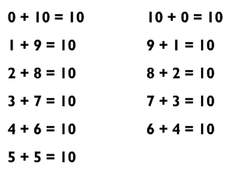

Key teaching points
1st key point: Our number bonds to 10 are always odd + odd OR even + even
2nd key point: Commutativity 6 + 4 = 4 + 6
3rd key point: We need to learn our number bonds to 10 off by heart!

Teaching progression:
Awareness of odd and even: Be able to identify numbers as odd or even, using Numicon as a visual image
Exploring different ways of making up 10: Using the Numicon for support, notice that the number bonds to 10 are always odd + odd or even + even
PRACTICE: Now you need to play LOTS of games until the children all know their number bonds to 10 off by heart. This is one of the sets which the children just need to memorise.
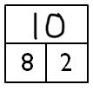
Represent in part-part whole models and in number sentences.
Pictorial: Represent this knowledge in part-part-whole diagrams

Abstract: Record this knowledge using number sentences; Model that these can be expressed commutatively and by partitioning the whole

Step 5: Adding 10 to a number

Images/manipulatives


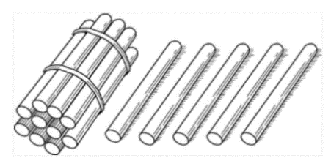
Base ten, e.g. straws, numicon

Key teaching points
1st key point: When we add 10 to a number we can use our place value knowledge to combine the numbers
2nd key point: Commutativity 10 + 5 = 5 + 10

Teaching progression:
Place value experience: Make up ‘teens’ numbers with place value equipment e.g. straws (or Numicon/Dienes).

Relate place value representation to notation: “This is the number fifteen. We write it 15 because there is one ten and five ones.”

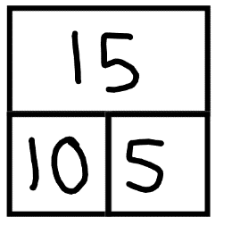
Pictorial: Represent this knowledge in part-part-whole diagrams

Abstract: Record this knowledge using number sentences; Model that these can be expressed commutatively and by partitioning the whole
Step 6: Adding 0 to a number

Images/manipulatives

Counters/straws/Numicon would all do here.

Key teaching points

1st key point: When we add 0 to a number we are adding nothing, and so our starting number remains the same. [Misconception here is that 7 + 0 = 0]
2nd key point: Commutativity 0 + 4 = 4 + 0

Teaching progression:
Practical experience of making up number sentences involving 0: Show me 0. Now add 4. How much do you have? Show me 4. Now add 0. How much do you have?

Stem sentence: “When we add 0, we don’t change the quantity.”

Pictorial: Represent this knowledge in part-part-whole diagrams

Abstract: Record this knowledge using number sentences; Model that these can be expressed commutatively and by partitioning the whole

Step 7: The ones without a family

The only remaining Y1 facts are 6 + 3 & 3 + 6 and 3 + 5 & 5 + 3. These just need to be learnt.
Fluent children often relate 6 + 3 to the counting in 3s pattern.


For 5 + 3 and 3 + 5 (indeed for any addition fact involving 5) children can be taught to recognise the standard “finger pattern” for 8 of 5 fingers and 3 fingers fairly easily, then this can be related to 5 + 3 and vice versa (incidentally it is worth getting all reception children to recognise 6, 7, 8, and 9 when presented in this way, then they already ‘know’ 5 + 1, 5 + 2, and 5 + 4 as well (they just need to be taught that they already know them!).

Step 8: Double 6, 7. 8 and 9

Images/manipulatives
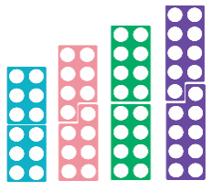

Double sided counters can model double 6, 7, 8 and 9 as double “5 and a bit” (i.e. double 8 is double 5 add double 3)

Numicon will allow the children to see that doubles of whole numbers are always even numbers

Key teaching points
1st key point: Doubles of whole numbers are always even
2nd key point: We need to learn our doubles off by heart!

Teaching progression:
[From Y1, children should be able to identify even numbers and know that a double means two lots of]
Teach as follows:
Double 6: use the clock face. 6 at the bottom, 12 at the top.
Double 7: explain that two weeks is called a fortnight because it has 14 nights. There are 7 days in a week, so double 7 is 14.
Double 8 & double 9: for a few children, remembering which is 16 and which is 18 seems particularly hard. There isn’t any substitute for practice here. Keep asking any target children this many times each day for a week, and keep a record of which children don’t yet know it.
Relating to inverse. What is half of 14 etc.
Once the facts are learnt, represent in part-part whole and equations as before.

Step 9: Near doubles

Images/manipulatives
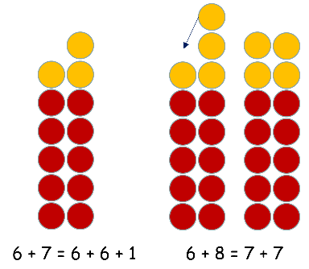
Adjacent numbers recognised as being ‘near doubles’ and ‘one up one down’ (i.e. second model shown here) is also a really nice efficient use of doubling.

Key teaching points
1st key point: I can add adjacent numbers by doing ‘double and 1 more’
2nd key point: I can add number with a difference of 2 (e.g. 6 + 8) by doubling the number in between them (i.e. by doubling 7 in this case)
3rd key point: Commutativity: 5 + 6 = 6 + 5

Teaching progression:
Fluency in doubles: Will already have been secured

Adjacent numbers: Will be double the smaller number, add 1. OR double the larger number, subtract 1.
Difference of 2:5 + 7, 6 + 8, 7 + 9
Then part-part whole and practice with equations as before

Step 10: Bridging

Images/manipulatives
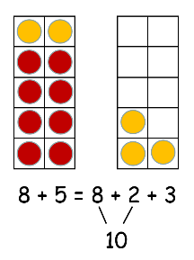
Tens frames

Key teaching points
1st key point: Bridging through ten can help us to calculate additions with a ‘teens’ total
2nd key point: Commutativity: 5 + 8 = 8 + 5

Teaching progression:

Partitioning single digit numbers: Children HAVE to be able to do this to bridge.
Calculating e.g. 8 + 5 by bridging requires partitioning the 5 into 2 and 3
What makes ten?: Children need to be able to make ten from 7, 8 and 9 (which are most likely
to be involved in bridging facts)
Tens frames (concrete): Make up the two quantities with counters on adjacent tens frames, then rearrange as shown above.
Symbolic: Practice recording as number sentences (as shown above)
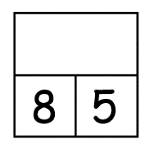
Part-Part Whole: Move to filling in PPW as shown here:

Number sentences (Abstract): Children in the end should be able to solve 8 + 5 (etc.)
presented as number sentences by thinking “8 + 2 + 3” in their heads
Comparison to other strategies: Highlight that we can also use e.g. near doubles to solve some bridging facts (e.g. 8 + 7)
Step 11: Compensating/adjusting

Images/manipulatives
The children should already be fluent in e.g. 5 + 10 and 10 + 5
5 + 10 = 15 so
5 + 9 = 14

Key teaching points
1st key point: By subtracting one from ‘add ten’ I get ‘add nine’
2nd key point: Commutativity (5 + 9 = 9 + 5)

Teaching progression
Fluency in adding ten: will already have been secured
Then PPW and practice with number sentences as before

Adding 8 and 7: Highlighting possibility of using compensating for adding numbers other than 9 (e.g. 8 and 7)
Comparison to other strategies: Highlight that we can also use near doubles and bridging to solve some compensating facts, e.g. 8 + 9

Early Years and Key Stage One NCETM Mastering Number Programme

In addition to incorporating the above strategies for fluency development in mathematics lessons, from September 2023 all Reception, Year One and Year Two children will take part in the new NCETM ‘Mastering Number’ Programme.

‘Mastering Number’, is a major new initiative from the NCETM and Maths Hubs. The year-long programme will run in thousands of primary schools from September 2021. Intack Primary School is part of the schools to take part in this exciting project. The programme is aimed at strengthening the understanding of number, and fluency with number facts, among children in the first three years of school.
Mastering Number is wholly consistent with and complementary to the Teaching for Mastery approach to mathematics teaching. This is the approach that teachers use when planning mathematics lessons in school.
Teachers of Reception, Year 1 and Year 2 will receive training and resources equipping them to give their class a daily short ‘number sense’ session as part of scheduled maths teaching outside of the maths lesson. The programme will last for the whole school year.
Children will have a daily ‘Mastering Number’ session outside of the usual maths lesson. These sessions will explicitly teach number facts and support fluency development. Over the year, children will use a range of materials and representations, including a small abacus-like piece of equipment called a rekenrek. The NCETM has provided a set of Rekenreks to school. The use of the Rekenrek supports the development of depth of conceptual understanding alongside fluency during the sessions. There are also teacher whiteboard resources and physical resources to enable children to take part in the sessions. Each year group has a long-term overview, medium term overviews and daily plans of the fluency sessions for teachers to follow.

Throughout the programme, children will develop conceptual understanding, fluency and confidence with the following key mathematical areas:

In Reception: Subitising, cardinality, ordinality, counting, composition of number, comparison of numbers and partitioning.

In Years One and Two: Subitising, cardinality, ordinality, counting, composition of number, comparison of numbers, partitioning and addition and subtraction number facts.

Fluency in Lower Key Stage Two

Developing fluency in multiplication and division facts
Children at Intack Primary School are provided with regular opportunities, both in class and through engaging homework activities, to develop times table’s knowledge. This ensures rapid recall of multiplication and division facts. Children in Key Stage Two experience times tables tests which show questions and numbers arranged in a variety of ways, using pictorial representations of numbers and missing number questions to develop flexibility and fluency with these facts. Using tests that that require children to think in a variety of ways about times tables, alongside the traditional recall of facts style of testing, ensures children develop depth of understanding and the flexibility to apply multiplication and division knowledge to unfamiliar contexts. See appendix 1 for examples of tests which promote depth of thinking with times tables facts.

Times tables songs and ‘Times Tables Rockstars’ are used to support the learning of times tables.

Fluency in times tables at Intack Primary School is reinforced through use of the very popular Times Tables Rock Stars programme. Children have the opportunity to use this at school and are encouraged to use it at home as daily times tables practice. The programme is used in classes in a competitive way and the children find the programme fun, engaging and motivating to use.



From Autumn Term 2024, Intack Primary school will be involved in the ‘NCETM Mastering Number Programme at KS2’. Children in Y4 will have a daily ‘Mastering Number’ session outside of the usual maths lesson. These sessions are designed to directly support children’s fluency by concentrating on the teaching and recall of number facts.
In preparation for the MTC tests in May, Year 4 children will also be introduced to the testing format, using the practice facility on the DFE website. This is to ensure the children are as prepared as possible for the testing procedure.

Fluency In Upper Key Stage Two.
The children in Year 5 will continue the ‘Mastering Number’ programme for another year. As in Year 4, this will be over and above the daily maths lesson. Children in Year 5 and continuing into Y6 will also practice times table derivatives to include:
- The multiplication/division link, for example 42÷7=? 7x? =42
- Comparing like times table facts in other tables, for example 6x4=24 = 8x3=24, 6x6 = 9x?
- Factoring up one side of the table fact to alter the answer, for example 2x6=12, so 4x6=24, and 8x6=48, finally 16x6=96.
- How powers of 10 produce a different answer, for example
6x3= 18, 60x3 = 180, 60x30= 1800, 600x3+ 1800, 0.6x3=1.8, 180÷3=60, 1.8÷3=0.6 etc.

A dedicated 10-15 minute slot will be included in daily maths lessons in Year 6 to allow revision and the practise of key arithmetic skills and techniques in preparation for the May SATS. Below are examples of question types to practice recall, deepen understanding and further knowledge of basic times table facts.

Appendix 1
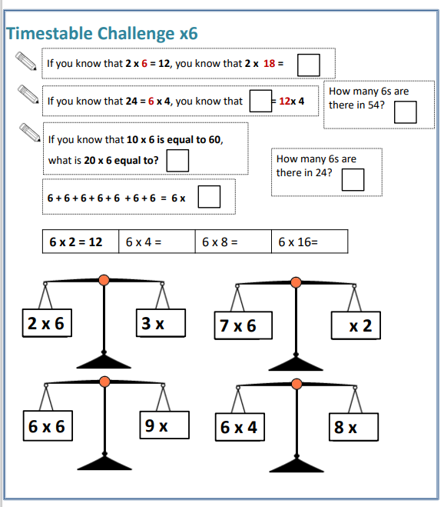

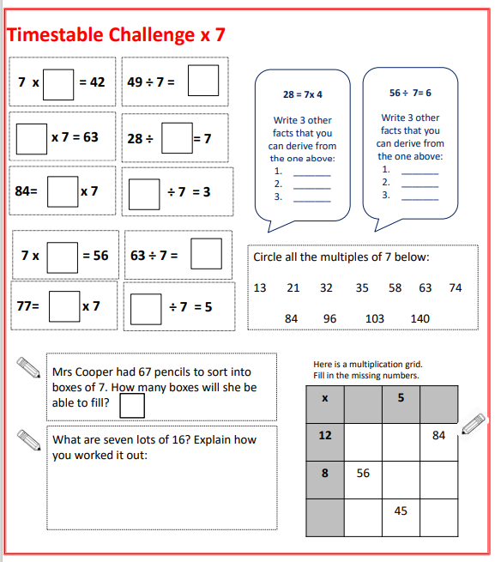

Glossary

Concrete - Concrete resources (also referred to as manipulatives) are objects or physical resources that children can handle and manipulate to aid their understanding of different maths concepts.

Pictorial - Once children are confident with a concept using concrete resources, they progress to drawing pictorial representations or quick sketches of the objects. By doing this, they are no longer manipulating the physical resources, but are still benefiting from the visual support the resources provide.

Abstract - Once children have a secure understanding of the concept through the use of concrete resources and visual images, they are then able to move on to the abstract.

Rekenrek –A physical resource to support conceptual understanding.

Stem sentence – A structured sentence starter or stem to support children’s conceptual understanding. The use of stem sentences provides children with a toolkit and the language to enable them to explain their mathematical understanding.

Commutativity – The law of commutativity applies to addition and multiplication calculations. For example, in an addition equation the addends can be added together in any order and the total is the same. This also applies to multiplication calculations as the factors can be multiplied in any order and the product is the same.

NCETM – National Centre for Excellence in the Teaching of Mathematics

Subitising – Instantly recognising the number of objects in a small group, without counting.

Cardinality - Cardinality is the ability to understand that the last number which was counted when counting a set of objects is a direct representation of the total in that group.

Ordinality – A number indicating position in a series or order.

Composition - Understanding that one number can be made up from (composed from) two or more smaller numbers. Knowing numbers are made up of two or more other smaller numbers involves ‘part–whole’ understanding.

Resources referred to in the Fluency policy which support conceptual fluency

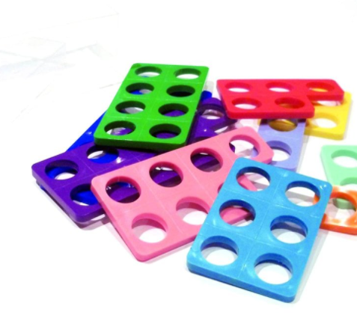

Rekenrek Numicon

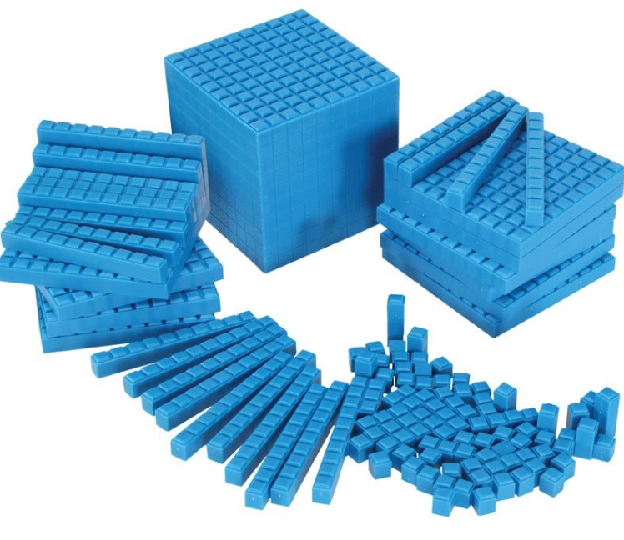
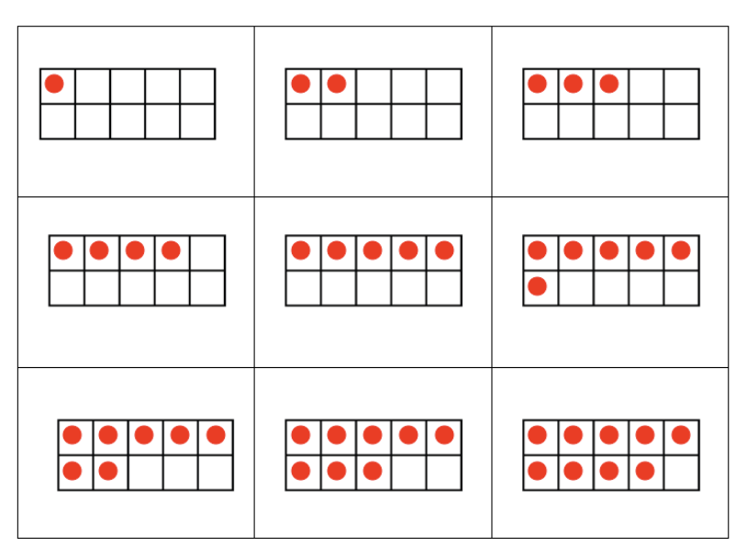
Ten Frame Dienes
Part-whole Model Bar Model


