Practise Your Spellings
Set 5 | Monday | Tuesday | Wednesday | Thursday | Friday
were
come
here
push
friend
school
poor
door
Please encourage your child to practise their spellings daily using the ‘look at the work, say the word, cover the word, write the word and check the spelling of the word’ method. Spelling tests will take place every week.
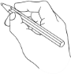
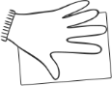
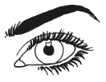
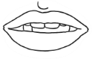

Look
Say
Cover
Check
Write

