Reception Curriculum Overview (2026-2027)
 | Autumn 1 –  It’s Good to be Me! | Autumn 2 –  Let’s Celebrate! | Spring 1 –  Winter Wonderland | Spring 2 –  Superheroes  (People Who Help Us & Transport) | Summer 1 –  The Great Outdoors  (Life Cycles, Minibeasts and Growing) | Summer 2 –  Amazing Animals
Key Learning  The ‘why’ | To settle into a new class, with new rules and routines.  To develop new relationships with teachers and peers.  To understand who they are and who is part of their family.  To develop confidence with accessing provision. | To develop an awareness of different festivals and celebrations in our community and around the world.  To develop mutual respect and tolerance for others and their beliefs. | To develop children’s knowledge and understanding of ‘cold’ place on our Earth.  To make children aware that there are other places on our Earth | To develop an understanding of different jobs and roles within our community.  To know that we can all be ‘super’ at different things.  To develop awareness of different vehicles. | To develop care and curiosity about plants and animals, including life cycles | To develop an understanding of and curiosity about different habitats and the animals that live there.
Characteristics of Effective Learning | Active Learning: I keep trying  Creative and Critical Thinking: I try new things  Playing and Exploring: I always have a go |  | Active Learning: I can concentrate  Creative and Critical Thinking: I find ways to solve problems  Playing and Exploring: I like to pretend and play |  | Active Learning: I am proud of my achievements  Creative and Critical Thinking: I make links in my learning  Playing and Exploring: I am interested in the world around me
WOW Themes | September: Friendship Month  9th Sept: National Teddy Bear Day (Ginger’s Birthday)  14th-20th Sept: Jeans for Genes Week  21st Sept: World Gratitude Day  October: Black History Month  4th Oct: Harvest Festival | 31st Oct: Halloween  Nov: Parliament Week  5th Nov: Bonfire Night  8th Nov: Diwali  9th – 13th Nov: Anti-Bullying Week  11-15th Nov: Nursery Rhyme Week  Nov: Children in Need  Nov: Road Safety Week  11th Nov: Remembrance Day  4th – 12th Dec: Hannukah  25th Dec: Christmas | 29th-31st Jan: Big Garden Birdwatch  1st-9th Feb: National Storytelling Week  1st-7th Feb: Children’s Mental Health Week  6th Feb: Chinese New Year  9th Feb: Pancake Day  14th Feb: Valentines Day | 4th March: World Book Day  7th March: Mothers’ Day  18th March: Global Recycling Day  20th March: Red Nose Day  20th March: Oral Health Day | 15th April: World Art Day  22nd April: Earth Day  23rd April: St George’s Day  7th May: National Space Day  11th-17th May: Mental Health Week  20th May: World Bee Day | 1st June: Dinosaur Day  5th June: Butterfly Awareness  8th June: World Ocean Day  June: Pride Month  20th June: Fathers’ Day  22nd June: Windrush Day  YES WEEK!
Enrichment Opportunities | Meet the teacher  Visit from a dental nurse  Teddy Bear’s Picnic (Ginger’s Birthday)  WellComm Parent Workshop | Pumpkin Picking / Carving  Making Pumpkin Soup / Bread  Phonics Parent Workshop  Visit from the lollipop man  Christmas Stay and Play  Christmas Carol Concert | Maths Parent Workshop  Making pancakes  Valentines Stay and Play  Forest School Bear Hunt  Pyjama Story Day | Recycling truck visit  Mothers’ Day Stay and Play  Visits from different people who help us | Caterpillar Life Cycle / Ladybird Life Cycles  Minibeast hunts  Reading Café | Chick / duck rearing  Fathers’ Day Stay and Play  End of year trip  YES Week!  Festival Week
British Value Focus | Rule of Law | Tolerance | Mutual Respect | Individual Liberty | Democracy | Recap the 5 values
Oral Storytelling Books | Goldilocks and the Three Bears | Little Red Hen | We’re Going on a Bear Hunt | The Three Little Pigs | The Very Hungry Caterpillar | Handa’s Surprise
Oral Storytelling Vocabulary | forest / cottage / porridge / big / small / medium-sized / sweet / salty / hard / soft / bear / growled | red hen / farm / wheat / grains / bull / cat / rat / water / cut / carry / mill / grind / knead / bake | bear / hunt / scared / grass / long / wavy / over / under / through / river / deep / cold / mud / thick / oozy / forest / dark / snowstorm / swirling / cave / narrow / gloomy | pig / farm / mother / house / straw / sticks / bricks / good / grand / strong / wolf / morning / evening / chinny chin chin / huff / puff / crashing / angry / leapt / chimney / stew | moon / egg / leaf / sun / caterpillar / ate / through / apple / pear / plum / strawberry / orange / hungry / pickle / swiss cheese / salami / stomach-ache / cocoon / nibbled / butterfly | delicious / basket / surprised / village / fruit / soft / banana / sweet / guava / round / juicy / ripe / mango / spiky / pineapple / creamy / avocado / tangy / passionfruit / tangerines / surprise
Core Theme Fiction Texts | Lulu’s First Day (1)  Starting School: The Colour Monster Goes to School (2)  Being You: Elmer (3)  Families: Our Class is a Family (4) | Halloween: Room on the Broom (1)  Diwali: Binny’s Diwali (2)  Autumn: The Leaf Thief (3)  Parliament Week: The Queens Hat (4)  Hibernation: Don’t Hog the Hedge (5)  Christmas: The Snowman (6) | Winter: The Snow Thief  Seasons: Stick Man  Winter: Snowball  Day and Night: Peace at Last  Polar Regions: Lost and Found  Pancake Day: Mr Wolf’s Pancakes | People Who Help Us: My Family of Heroes  Minibeasts: Superworm  Recycling: Somebody Crunched Colin  Superheroes: A Superpower Like Mine  Superheroes: Super Duper You  Superheroes: I Love Me | Traditional Tale: The Enormous Turnip  Planting: Luna Loves Gardening  Food: Oliver’s Vegetables  Life Cycles: The Woolly Bear Caterpillar  World Bee Day: Lula Meets the Bees  Space: Whatever Next | Dinosaurs: Harry and the Bucketful of Dinosaurs  Ocean: Rainbow Fish  Africa: Handa’s Surprise  Farm: Farmer Duck  Africa: The Ugly Five  Ocean: The Turtle Who Turned the Tide  Jungle: Monkey Puzzle
Core Theme Fiction Vocabulary | Lulu’s First Day  school / friend / bag / water bottle / uniform / peg / reading area / dressing up / goodbye / snack time / construction area / circle time / home  The Colour Monster Goes to School  school / rucksack / coat / bookbag / friend / classroom / story time / playground / toilet / hall / lunchtime / PE / happy / sad / angry / calm / scared / love  Elmer  different / same / happy / pleased / serious / joking / laughter / silent / surprise / celebrate  Our Class is a Family  Family / house / special / classroom / respect / kindness / memories / differences / unique / mistakes/ try / teacher / friend | Room on the Broom  witch / hat / grinned / broomstick / wind / wildly / down / searched / room / broom / stormy / bow / wand / snapped / mean / cauldron / spell  Binny’s Diwali  happy / nervous / Diwali / festival / light / Indian / sari / gifts / jalebis / pedas / sweet / soft / milky / oil lamps / diyas / shy / scared / hindu / fireworks / sparklers / rangoli patterns / remembrance / soldier / war / poppy / died  The Leaf Thief  Nest / hazelnuts / red / gold / orange / stole / thief / leaf / trees / wind / autumn  The Queen’s Hat  Queen / wind / hat / soared / strong / Trafalgar Square / London Zoo / London underground / London Eye / Tower Bridge / Big Ben / Kensington Palace / above / through / around / across / over / down  Don’t Hog the Hedge  hedgehog / hibernation / winter / crispier / snuggled / drifting off / hedge / dormice / nest / comfortable / companions / Queen Bee / safe / sobbed / shelter / bat  The Snowman  snow / glistening / snowball / rolled / evening / snuggled / crept / fire / fridge / hot / cold / North Pole / Father Christmas / soared | The Snow Thief  white / cold / snow / winter / warm / round / snowball / snowflakes / frozen / ice / skating / thief / stole / melted  Stick Man  stick / family tree / hop / twirl / river / floating / nest / mast / flag / lonely / lost / frozen / frost / weary / doze / snow  Snowball  alone / round / snowball / gazed / mission / twig / stumble / tumble / rolled / skidded / bounced / pebble / stick / pocket / crash / lonely / friend  Peace at Last  late / bear / tired / snore / aeroplane / bedroom / living room / clock / kitchen / leaky / tap / refrigerator / garden / owl / hedgehog / uncomfortable / peace / alarm-clock / yawned  Lost and Found  penguin / sad / lost / found / floated / disappointment / discovered / South Pole / harbour / ship / horn / row / rowboat / strength / waves / delighted / lonely / searched  Mr Wolf’s Pancakes  hungry / pancakes / delicious / recipe / neighbours / slammed / ingredients / list / money / basket / eggs / milk / flour / cooking / sad / gobbled | 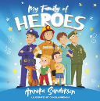  My Family of Heroes  TBD  Superworm  long / strong / wiggle / road / disaster / bored / cheer up / skipping-rope / well / drowning / fishing-line / toad / beetle / bee / bug / snail / slug / ant / earwig / crow / hero / wizard / power / fright / rubbish dump  Somebody Crunched Colin  scrunched / hovered / scent / creeping / crawled / ducked / clutching / crunched / shiver / river / tangle / trapped / wave / soggy / swooped / stuck / kind / bin / reuse / recycle / watering can / plastic  A Superpower Like Mine  superpowers / inside / special / funniest / laugh / smart / brain / kind / caring / kindness / creative / imagination / patience / bravery / listening  Super Duper You  Frills / jewels / bows / twirls / tippy-toes / brave / stomp / baddie / cuddly / polka dotty / stripes / different / bold / proud / brilliant  I Love Me  mirror / proud / brave / powerful / strong / smart / tall / kind / happy / cheer / smile / loving / beautiful / important / honest / grateful | The Enormous Turnip  cottage / planted / turnip / seeds / rows / grew / pulled / budge / bulged / called / old man / old lady / breakfast / lunch / dinner / soup  Luna Loves Gardening  Gardening / digging / wellies / watering can / watering / seeds / planting / garden / mud / plants / potatoes / bug hotel / pond / pollinate / fruits / vegetables / dragonflies / beetroot / carrots / scattered / rows / hole / soil / bare / roots / shoots / weeds / corn / harvest  Oliver’s Vegetables  garden / grow / vegetables / potatoes / complaint / carrots / crinkly / leaves / spinach / rhubarb / hurried / slugs / snails / cabbages / beetroot / peas / soup / delicious / rushed / scrub / peel / cut  The Woolly Bear Caterpillar  Caterpillar / garden / dandelion / leaves / gardener / flower bed / crawl / sycamore tree / moth / wings / plain / dull / tall / twig / sad / dock leaf / cocoon / hatch / fluttered  Lula Meets the Bees  beekeeper / bees / flower / pollen / garden / park / hive / roof / worker bees / nectar / bee dance / honey bees / sting / suit / baby bees / honey / cell / queen bee / brood box / super / sweet / sticky / delicious / seeds  Whatever Next  moon / rocket / space helmet / space boots / colander / journey / chimney / smart / roared / passengers / stars / boring / state / gasped / | The Dinosaur Next Door  Street / neighbour / next door / expert / Brachiosaurus / long neck / palaeontologist / museum / dinosaur / extinct / million / bakery / cakes / delight / leaves / flowers / tunnel / curious / discovery / crowd  Rainbow Fish  Deep / sea / ordinary / fish / ocean / scales / amazed / proud / silent / shocked / dazzling / shimmering / loneliest / starfish / coral reef / cave / octopus / delighted / friends  A Squash and a Squeeze  Grumble / squash / squeeze / hen / curious / plan / tiny / goat / chewed / trod / nibble / titchy / pecks / fleas / pig / chasing / raiding / teeny / cow / charged / weeny / enormous / gigantic  One Day on Our Blue Planet: In the Savannah  sun / rises / savannah / Africa / lioness / cub / den / safe / hidden / pride / roar / tall grass / river / precious / hunting / growling / stalking / chasing / prey / night / moon  The Turtle Who Turned the Tide  Not available on YouTube  Monkey Puzzle  lost / butterfly / elephant / grey / curly / trunk / baggy knees / tail / coils / snake / slither / hiss / nest / eggs / spider / hairy / treetops / above / parrot / beak / claws / feathery wings / leaps / frog
Core Theme Non-Fiction Texts | All About Families (5)  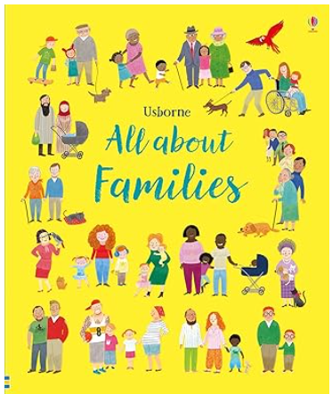  My Body Parts (6)  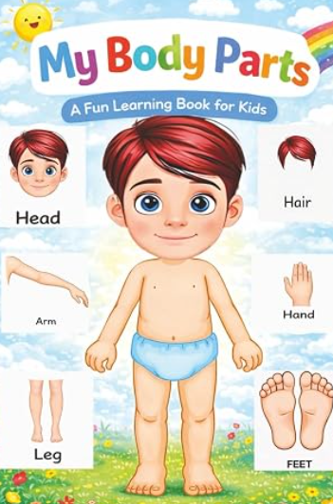  My Body (My Little World) (7)  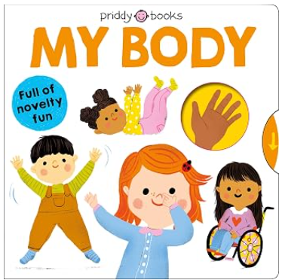 | I Love the Seasons: Autumn (2)  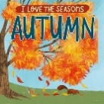  The Nativity Story (RE)  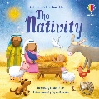 | I Love the Seasons: Winter  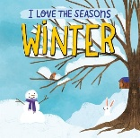  Chinese New Year | I Love the Seasons: Spring  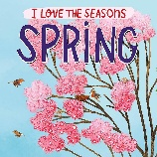  Selection of people who help us books  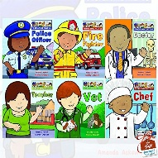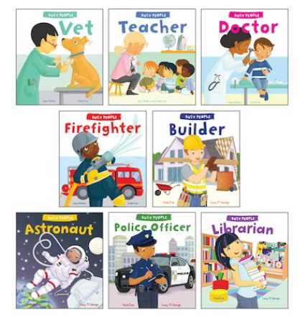 | Selection of life cycle books  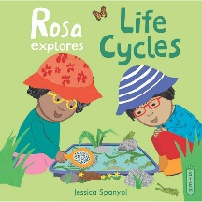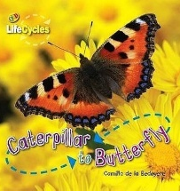 | I Love the Seasons: Summer  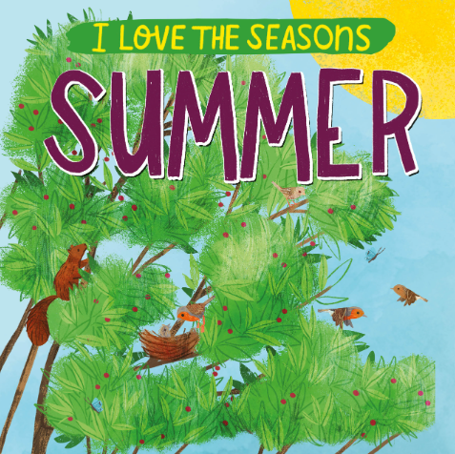  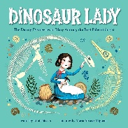
Core Theme Rhymes / Songs | Handwashing song  Draw a Portrait  My Body Song  My Senses Song  My Special People Song  We Use Our Hands to Draw and Play  Dingle Dangle Scarecrow | Halloween: Pointy Hat  Harvest: Chop Chop  Autumn: Leaves Are Falling  Parliament Week : London Bridge is Falling Down  Bonfire Night: Firework Number Rhyme  Christmas: A Little Frosty Snowman  Christmas Carols Song | Winter: I Can Build a Snowman  Pancake Day: Pancakes  Valentines Day: Popcorn  Winter: Carrot Nose  Hibernation: The Fox | Weather: Pitter Patter  Spring: 5 Little Speckles Frogs  Superheroes: I’m a superhero because…  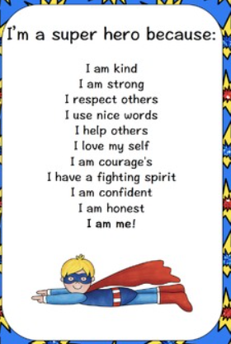  People Who Help Us: Finger Family Song | Planting: A Little Seed  Habitats: Mrs Bluebird  Minibeasts: A Little Shell  Growing Vegetables: Five Little Peas  Minibeasts: Under a stone | Animals: The animals went in two by two  Jungle: Monkey Babies  Ocean: The big ship sails on the ally ally oh  Jungle: Down in the jungle
Core Theme Vocabulary | family / big / small / mum / dad / brother / sister / pet / grandma / grandad / family tree / love | harvest / tractor / farm / farmer / corn / vegetables / berries / combine harvester / halloween / pumpkin / ghost / spider / bat / bonfire night / bonfire / fireworks / sparklers / flames / toffee apples / toasted marshmallows / Guy Fawkes / London / Houses of Parliament / Big Ben / Queen / King / remember / poppy / soldier / war / died / silence / parade / Diwali / diya lamps / festival / light / rangoli patterns / Hannukah / menorah / light / Hindu / Judaism / winter / Father Christmas / Santa / advent calendar / gifts / Jesus / Mary / joseph / stable | winter / snow / ice / frozen / frost / bare trees / freezing / iceberg / melted / snowflakes / snowball / igloo / icicles / ocean / Arctic / Antarctica / North Pole / South Pole / Earth / England / Greenland / polar bear / penguin / seal / walrus / reindeer / arctic fox / arctic hare | superpower / superhero / doctor / nurse / paramedic / ambulance / vet / dentist / firefighter / fire engine / police officer / police car / builder / bulldozer / cement mixer / excavator / strong / powerful / brave / kind / courageous / confident / honest | plant / soil / seeds / water / sunlight / dig / trowel / spade / rake / grow / air / fruit / vegetables / flowers / sunflower / cress / bulbs / pot / watering can / fork / hoe / gloves / daffodils / tulips / vase | africa / savannah / hot / sunny / trees / zebra / lion / elephant / giraffe / rhino / hippo / antelope / gazelle / safari / dry / ostrich / cheetah / ocean / fish / octopus / shark / puffer fish / jellyfish / starfish / sea / waves / sand / crab / turtle / seahorse / coral reef / shells / scuba diver / submarine / anchor / dinosaurs / extinct / fossils / palaeontologist / skeleton / bones / teeth / volcano / farm / farmer / tractor / farmhouse / field / grass / barn / pond / haybale / pig / cow / bull / sheep / goat / donkey / horse / dog / cat / chicken / hen / goose / duck / rabbit / jungle / monkey / snake / parrot / tropical / damp / hot / rainforest
Communication and Language | Ginger’s Listening Rules  Social phrases: ‘Good Morning…’. ‘Please can I have…?’ and ‘Please can I go…?  1:1 show and tell opportunities  Questions: who / what / where / when / why | Repeated refrains in stories  Asking ‘who’ questions  Small group show and tell opportunities  Following and describing the routine of the day using the visual timetable | Talk about key events in a stories  Asking ‘what’ questions  Key worker group show and tell opportunities  Describing events in detail | Talking about characters’ feelings  Asking ‘where’ questions  Using ‘and’ to join words and clauses | Linking events in stories to real-life experiences  Asking ‘when’ questions  Sharing news about experiences and interests in whole class scenarios, using the past tense | Hot seating characters from stories  Asking ‘why’ questions  Using past and present tense accurately
Personal, Social and Emotional Development | Me and My Relationships | Valuing Difference | Rights and Respect | Keeping Safe | Growing and Changing | Being My Best
Physical Development | Fundamental Movement Skills – walk, run, hop, skip, jump & climb  Bikes and scooters  Climbing Frame  Assault Course  Dough Disco  Squiggle While You Wiggle  Drawing Club  Cutting Skills Station  Threading Station  Early Mark Making | Fundamental Movement Skills – walk, run, hop, skip, jump & climb  Dance  Bikes and scooters  Climbing Frame  Assault Course  Dough Disco  Squiggle While You Wiggle  Drawing Club  Cutting Skills Station  Threading Station  Early Mark Making | Fundamental Movement Skills – walk, run, hop, skip, jump & climb  Rolling, Throwing & Catching Skills  Bikes and scooters  Climbing Frame  Trim Trail  Assault Course  Dough Disco  Handwriting  Drawing Club  Cutting Skills Station  Threading Station  Drawing Studio  Cutlery | Fundamental Movement Skills – walk, run, hop, skip, jump & climb  Kicking & Passing Skills  Bikes and scooters  Climbing Frame  Trim Trail  Assault Course  Dough Disco  Handwriting  Drawing Club  Cutting Skills Station  Threading Station  Drawing Studio  Cutlery | Fundamental Movement Skills – walk, run, hop, skip, jump & climb  Gymnastics & Yoga  Bikes and scooters  Climbing Frame  Trim Trail  Assault Course  Dough Disco  Handwriting  Drawing Club  Cutting Skills Station  Threading Station  Drawing Studio  Cutlery | Fundamental Movement Skills – walk, run, hop, skip, jump & climb  Batting & Aiming  Bikes and scooters  Climbing Frame  Trim Trail  Assault Course  Dough Disco  Handwriting  Drawing Club  Cutting Skills Station  Threading Station  Drawing Studio  Cutlery
Literacy | Comprehension: identifying characters in a story  Word Reading: identifying and enunciating initial sounds  Narrative Oral outcome: retell of ‘Goldilocks and the Three Bears’  Narrative Written outcome: initial sounds for objects / name writing  Non-Fiction Written outcome: initial sounds for members of their family / name writing | Comprehension: identifying settings in a story  Word Reading: blending CVC words  Narrative Oral outcome: retell of Little Red Hen (possible simple innovation)  Non-Fiction Oral outcome: instructions on how to make bread  Narrattive Written outcome: CVC words and simple labels for the characters in the story (with support if needed)  Non-Fiction Written outcome: CVC words and simple labels for ingredients and actions (with support if needed) | Comprehension: identifying key events in a story  Word Reading: identifying digraphs and beginning to blend these in words  Narrative Oral outcome: retell of We’re Going on a Bear Hunt with a simple innovation  Narrative Written outcome: CVC words and simple labels, using phase 3 digraphs  Non-Fiction Written Outcome: simple labels for a bear | Comprehension: discussing non-fiction books  (People Who Help Us)  Word Reading: blending phase 3 words and beginning to chunk longer words  Narrative Oral outcome: innovation of the ‘The Three Little Pigs’  Narrative Written outcome: dictated simple captions from the story  Non-Fiction Written outcome: simple captions to describe a wolf / pig (or innovated character) | Comprehension: to answer questions about a story  Word Reading: reading simple phase 3 captions and simple sentences  Non-Fiction Oral outcome: explanation for the life cycle of a caterpillar  Fiction Written Outcome: simple, repetitive sentences of what the caterpillar ate (can be innovated)  Non-Fiction Written outcome: simple sentences about the life cycle of a caterpillar | Comprehension: using vocabulary learned in context in and outside the literacy lesson  Word Reading: reading simple phase 3 captions and simple sentences, including longer words with suffixes  Oral outcome: documentary video for the savannah  Fiction Written outcome: simple sentences about what Handa packed in her basket  Non-Fiction Written outcome: simple sentences about a chosen habitat
Writing opportunities  (adult-led and enhancements for provision) | Initial Sounds • Letter Formation • Name writing • Draw images and write labels | Name writing • Letter formation  • Beginning to write letter sounds at random • Label a plan • Write a caption • Speech bubbles | Create a story map • Write labels / captions / sentences describing a character • Speech bubbles | Create a story map • Write labels / captions / sentences describing a character • Speech bubbles | Writing repetitive sentences | Writing simple sentences
Maths | Match, sort and compare  Talk about measures and patterns  It’s Me! 1, 2, 3! | 1, 2, 3, 4, 5,  Circles and Triangles  Shapes with 4 sides  Consolidation | Alive in 5  Growing 6, 7, 8  Length, height and time | Building 9 and 10  Explore 3D Shapes | Sharing and grouping  How many now?  Counting to and beyond 20  Manipulate, compose and decompose | To 20 and beyond  Mass and Compacity  Consolidation (GLD assessment)  Visualise, build and map
Understanding of the World  **when teaching seasons, refer to the Plymouth Science unit too | Science  All About Me  History  Can you guess who?  My Life’s Timeline  Family Tree  Toybox  Geography  Senses in Nature  Our school from above  Let’s Build a Map  RE  I am Special  Harvest | Science  Celebrations  History  Wearing the Crown  Remembrance  Geography  Exploring Seasons  Dress the teddy  Journey Sticks  London  Road Safety  RE  Christmas | Science  Materials  History  Past and Present  Spot the difference  Geography  Exploring the Seasons  Dress the teddy  Comparing Greenland and UK  RE  Special Places | Science  People Who Help Us  History  My Achievements  Transport through time  Geography  Exploring the Seasons  Nature catchers  Investigating Maps  RE  Easter | Science  Plants and Growing  History  Picture Detective  Geography  Exploring the Seasons  Map Making  Observational Painting  RE  Stories Jesus Told | Science  Under the Sea  History  Dinosaurs  Geography  Exploring the Seasons  Dress the teddy  Around the World  RE  Prayer
Seasons & Weather – observations

Expressive Arts and Design | Art  Drawing Marvellous Marks (Art)  Music  Me! | Art  Painting My World – Part 1  DT  Cooking and Nutrition  Seasonal Crafts: Hibernation Boxes  Music  My stories | Art  Winter Crafts  DT  Textiles  Seasonal Crafts: Sliding Santa Chimneys  Music  Everyone! | Art  Let’s Go Crafty  DT  Junk Modelling  Seasonal Crafts: Hanging Egg Decoration  Music  Our World | Art  Painting My World – Part 2  DT  Seasonal Crafts: Flower Threading  Seasonal Crafts: Designing a rainbow salad  Seasonal Crafts: Making a rainbow salad  Music  Big Bear Funk | Art  Sculpture and 3D – Creation Station  DT  Structures  Music  Reflect, Rewind, Replay

